Part 1:

1.

Let be 0.

Magnitude:



Angle:



2.

|  |  |  |
| --- | --- | --- |
| Input Frequency ( rad/s) | (V) | (Degrees) |
|  |  |  |
|  |  |  |
|  |  |  |
|  |  |  |
|  |  |  |

3.

:

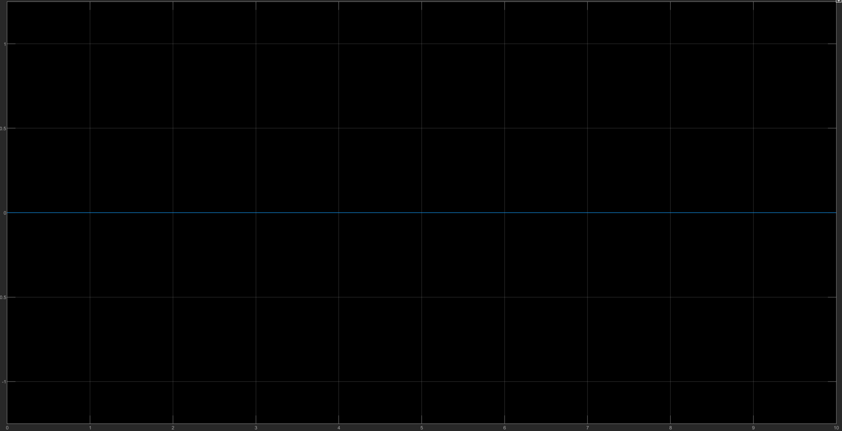

:

:

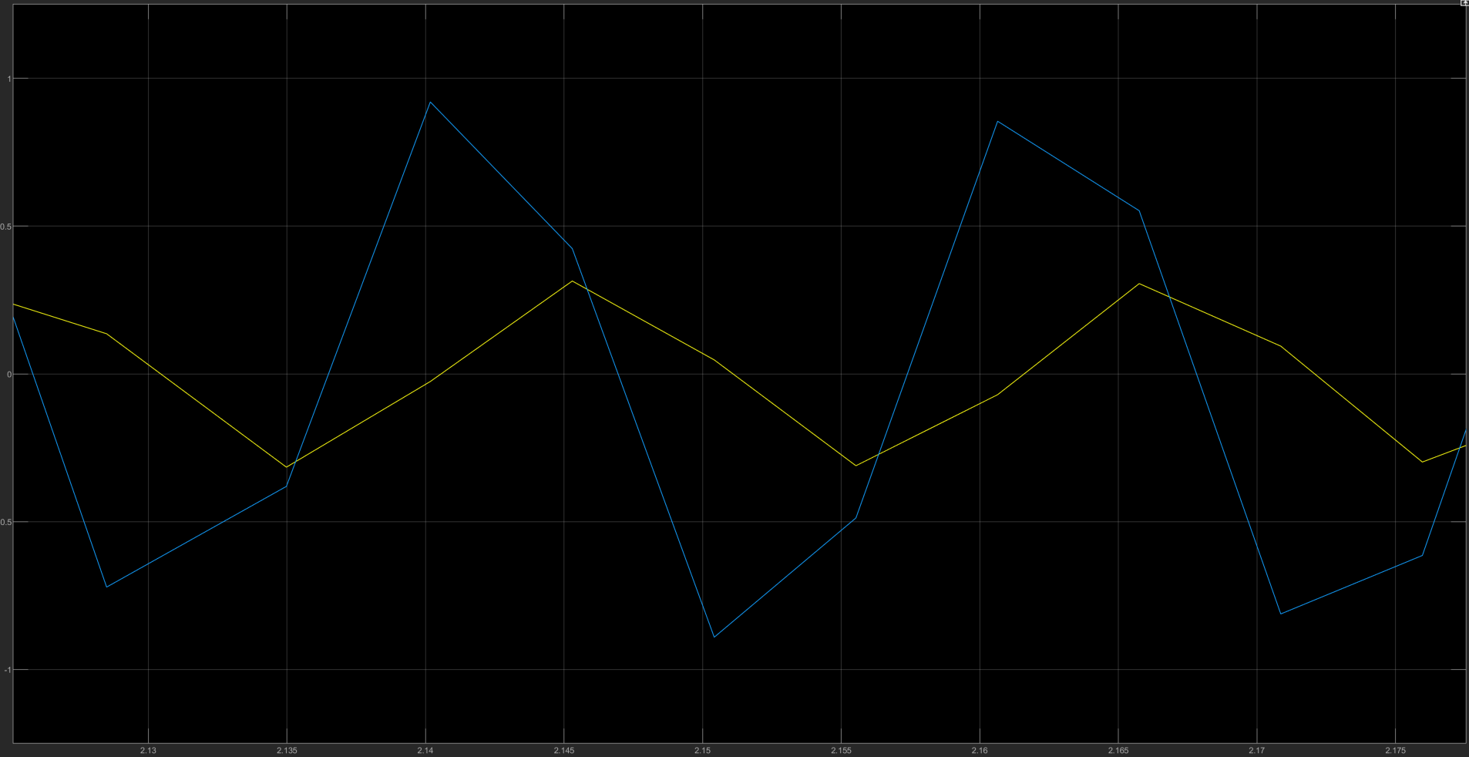

:

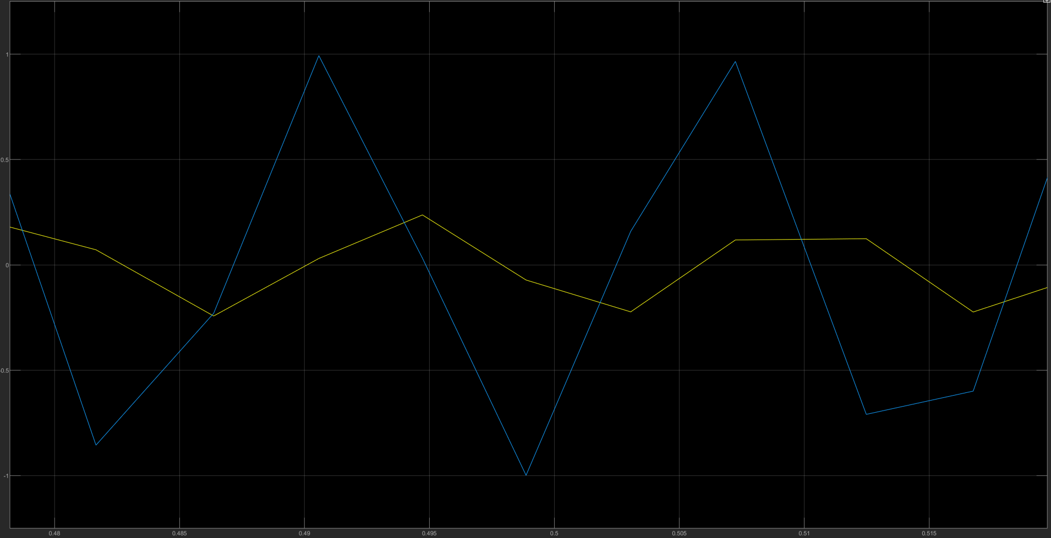

:

4.

At high frequency, the input signal is much larger in magnitude than the output signal. As such, the system appears to block such input, thus being a low-pass filter due to only having measurable output with lower input frequencies.

Part 2:

a.

b.

With :

Without :

c. Despite the residual noise, the model with (Blue line) captures the actual signal the most accurately. This is because the other two models transition values too late to accurately resemble the intended value of each time it changes values.